South Dakota School of Mines and Technology
Department of Materials and Metallurgical Engineering

Met 624 Homework #10 Apr 24, 2014

Select four sequential relationships from the table below and derive the shown result.

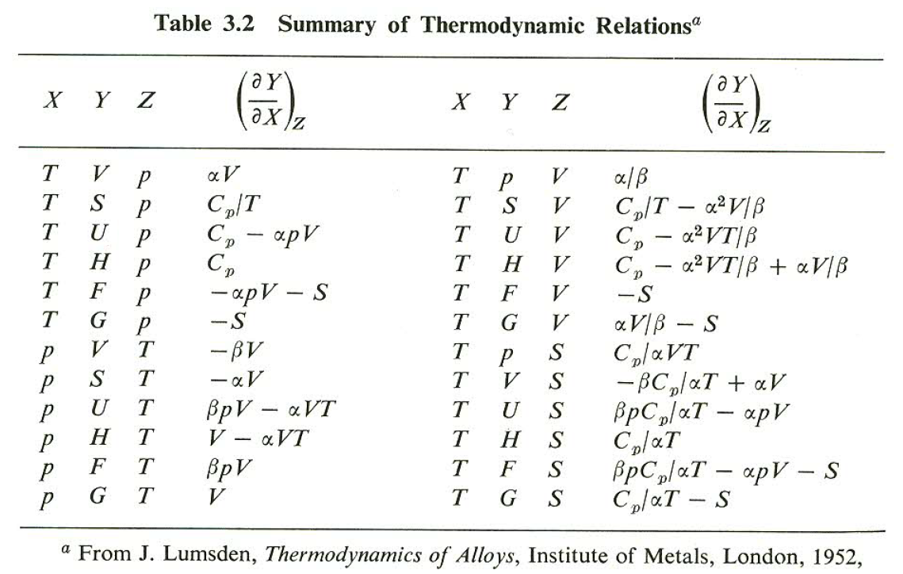

Ref: Richard A. Swalin, Thermodynamics of Solids, John Wiley and Sons, New York, 1961, p50.

