South Dakota School of Mines and Technology
Department of Materials and Metallurgical Engineering

MET 320 HQ 3 Nov. 21, 2014

SEE THE DATA AT END OF EXAM - NO CALCULATORS – CLOSED BOOK AND NOTES
– NO DATA SHEET
If a problem seems to be in error, state the trouble, state an assumed correction, and proceed.

- Do any 5 of the following 10 parts (a) – (j) using the attached Ellingham Diagram.
Only the first five worked will be graded.

- Find the pressure of O₂ in equilibrium with Si and SiO₂ at 1000 °C

- Find the CO/CO₂ ratio in equilibrium with Si and SiO₂ at 1000 °C

- Estimate the Heat of Fusion for Mn

- Determine the direction of the reaction 2Mn + SiO₂ = Si + 2MnO at 1200 °C

- Darken the line(s) that show(s) the relative oxygen potential fixed by C.

- Label a circle showing the general region of the most noble metals on the diagram.

- Label a circle showing the general region of the most stable oxides on the diagram.

- Draw an arrow on the diagram showing the direction of decreasing oxygen potential.

- Describe what you think would the equilibrium condition would be if a large amount of SiO₂ and Si were placed in a reactor with a relatively small amount of Mg, and MgO at 1200 °C.

- Write three of the four labels (or names) for the vertical scale of the Ellingham diagram?

- Answer ANY 4 of the following 7 short answer questions.
The first four answered will be graded.

- What is the difference between ΔG and ΔGº?

- How many roots does an equation of state for a real gas have for volume at a fixed temperature below the critical temperature?

- What event (behavior) determines the critical temperature?

- By what method does one get one partial molar quantity from another partial molar quantity?

- What is the definition of the activity coefficient?

- What is Darken’s Quadratic Formalism?

- Given a liquidus temperature, what five values are needed to compute activities from the phase diagram?

3. Show how to find the Gibb’s Energy change and direction of the reaction at 1100 K for

PbO_{(l)} + SO₂ + ½ O₂ = PbSO_{4(s)}

when the pressure of SO₂ is 0.1 atm; the pressure of O₂ is 2 atm; the activity of PbO is 1 relative to pure, solid PbO; and the PbSO₄ is pure, solid.

Data

O U T P U T F R O M T H E R M O - C A L C
2014.11.20 18.27.35
Reaction: O2S1+O1PB1+0.5O2=O4PB1S1
O2S1 stable as GAS
O1PB1 stable as O1PB1_S
O2 stable as GAS
O4PB1S1 stable as O4PB1S1_S
***************************************************** |  |  |  | **********
T | Delta-Cp | Delta-H | Delta-S | Delta-G
(K) | (Joule/K) | (Joule) | (Joule/K) | (Joule)
***************************************************** |  |  |  | **********
298.15 | 3.24E+00 | -4.08E+05 | -2.70E+02 | -3.27E+05
300 | 3.12E+00 | -4.08E+05 | -2.70E+02 | -3.27E+05
400 | 1.33E+00 | -4.08E+05 | -2.70E+02 | -3.00E+05
500 | 4.69E+00 | -4.07E+05 | -2.69E+02 | -2.73E+05
600 | 1.05E+01 | -4.07E+05 | -2.68E+02 | -2.46E+05
700 | 1.90E+01 | -4.05E+05 | -2.66E+02 | -2.19E+05
800 | 2.78E+01 | -4.03E+05 | -2.63E+02 | -1.93E+05
900 | 3.73E+01 | -4.00E+05 | -2.59E+02 | -1.67E+05
1000 | 4.73E+01 | -3.96E+05 | -2.55E+02 | -1.41E+05
1100 | 5.77E+01 | -3.90E+05 | -2.50E+02 | -1.16E+05

4. Write the first 4 of Big 6 equations (exclude aqueous state) and describe the standard state for each.

5. A vessel maintained at a constant pressure of 10 atm is filled with 20 moles of H₂, 50 moles N₂, and 3 moles of NH₃. The gases react to equilibrium. Show how to find the equilibrium moles of NH3.

N2+ 3H2 = 2NH3 K=2.11

6. a) How many degrees of freedom are there in a system consisting of three condensed phases: one is primarily Fe_{(l)}, one is primarily FeO _{(s)}, and one is primarily C_{(s)}. There are two gas species: CO_{2(g)} and CO_{(g)}? CO, CO₂, and C establish equilibrium as does the FeO with C to make CO and Fe.

b) How much difference would the consideration of O₂ coming from the reaction

CO₂ = CO + 0.5 O₂

have on the computation of the degrees of freedom?

7. How many gmoles of CO₂ would be contained in a 22.4 liter volume at 304 K and 1.4 times its critical pressure of 73 atm?

8. Use the data sheet provided for the Ag-Al system. How much heat would be expected from mixing
a) One mole of liquid Al at 1338 K and 9 moles of liquid Au at 1338 K?

  - Three mole of liquid Al at 1338 K and 1,000,000 moles of liquid Al-Au alloy of X_{Al} = 0.3 at 1338 K?

DATA from Hultgren, et al. All G and H data are in calories. All S data are in calories/K
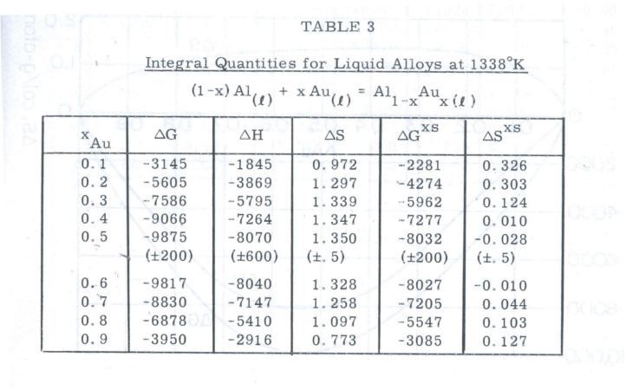
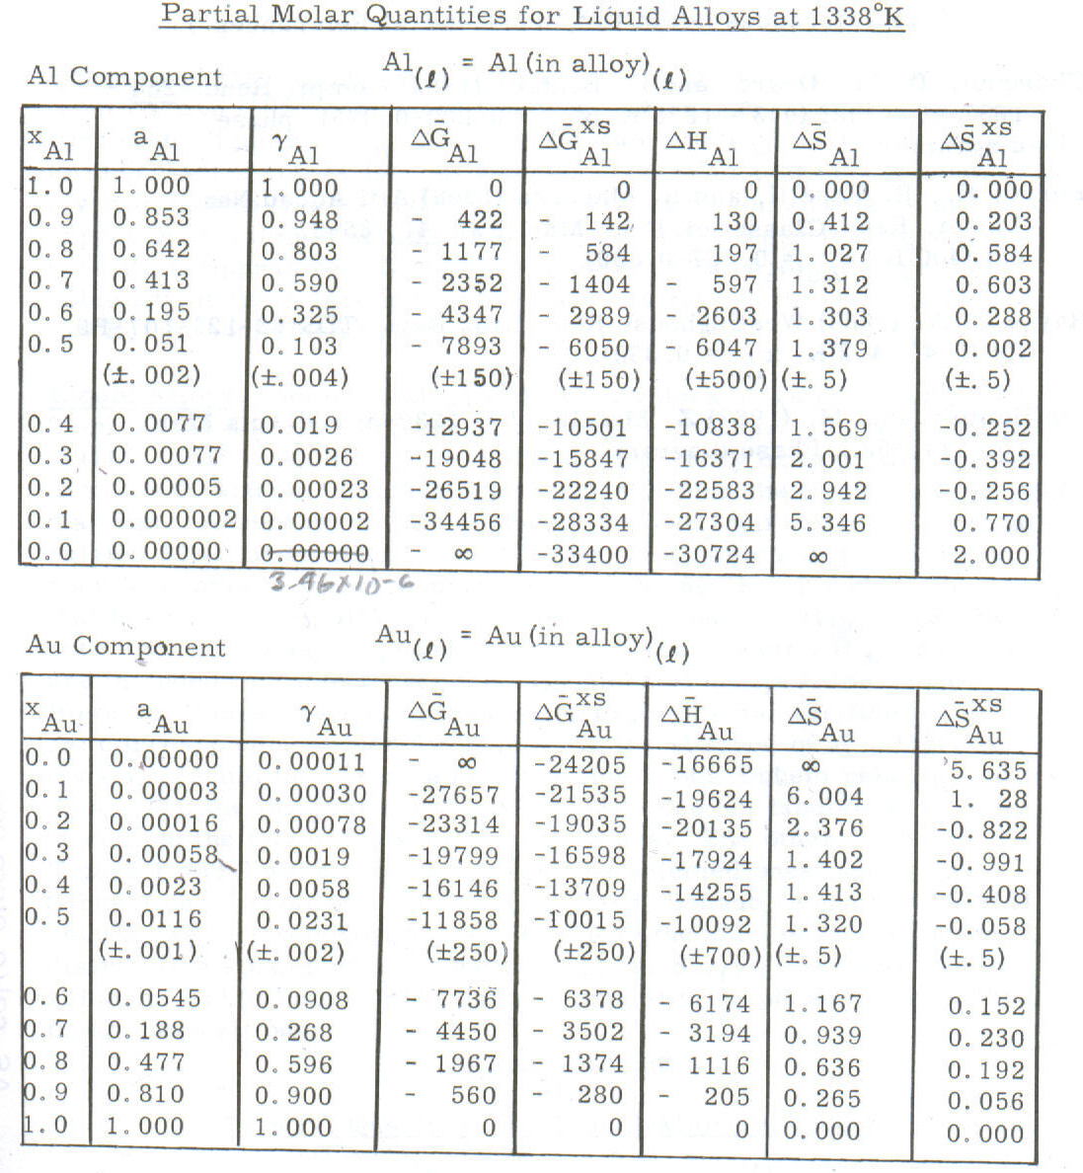
0.000035

Data Sheet
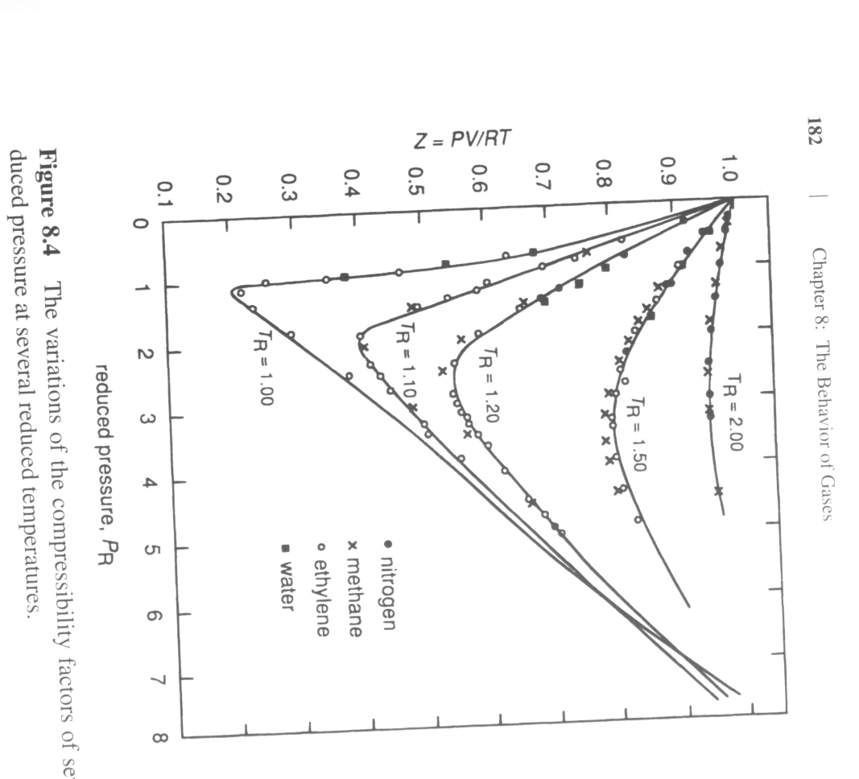
Ref: David R.Gaskell, Introduction to the Thermodynamics of Materials, 5th ed.

Critical properties for selected gases
Gas | T_{cr}, K | P_{cr}, atm | V_{cr} , cm³/mole
He | 5.3 | 2.26 | 57.6
H₂ | 33.3 | 12.8 | 65.0
N₂ | 126.1 | 33.5 | 90.0
CO | 134.0 | 35.0 | 90.0
O₂ | 15.4 | 49.7 | 74.4
CO₂ | 304.2 | 73.0 | 95.7
NH₃ | 405.6 | 111.5 | 72.4
H₂O | 647.2 | 217.7 | 45.0
Ref: David R.Gaskell, Introduction to the Thermodynamics of Materials, 5th ed.

Ellingham Diagram
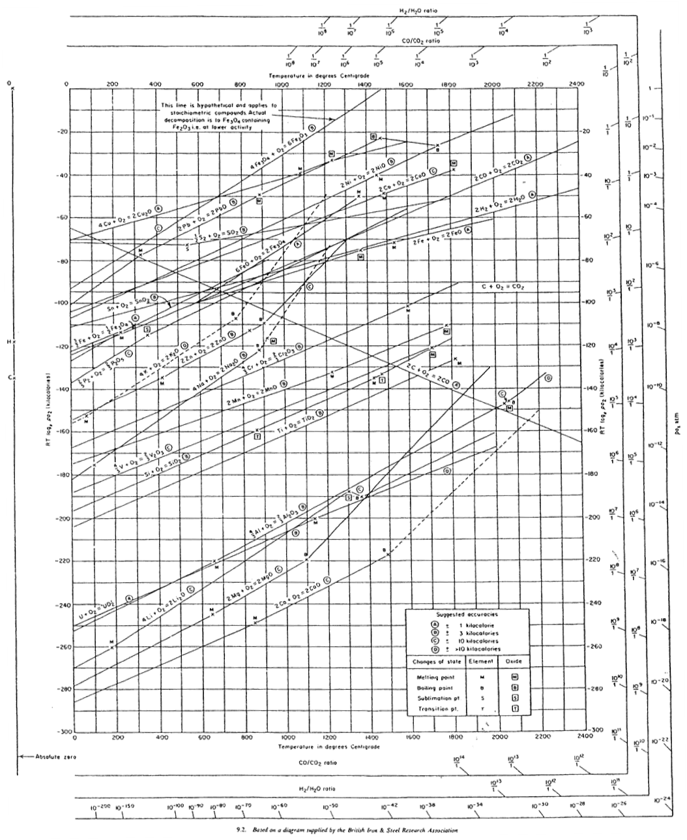

Scratch paper – detach and discard

