SOUTH DAKOTA SCHOOL OF MINES AND TECHNOLOGY
DEPARTMENT OF MATERIALS & METALLURGICAL ENGINEERING

MET 320 Final Exam Dec. 16, 2014
Closed book notes and calculator

Constants:
R = 1.987 cal/K•gmole = 8.31 J/K•gmole
F = 23,061 cal/volt•gram equivalent = 96,485 Joule/volt•gram equivalent

1. Two moles of an ideal gas at 1 atm and 300 K are adiabatically compressed to 8 atm.
a) What is the final temperature?

b) How much heat was required?

c) How much work was required?

- Pure, liquid TiCl₄ at 400 K is to undergo electrolysis to form Cl₂ gas at a pressure of 0.1 atm and pure, solid Ti. What cell potential is needed?
 | Melting Point, K | Boiling Point, K
TiCl₄ | 249 | 403

3. Estimate the vapor pressure of water at room temperature (298 K). The heat of vaporization for water is 61,430 J/gmole.

4. What is the maximum amount of work that could be obtained from 1000 BTUs of heat from a boiler at 500 K if the coldest heat sink available is at 300 K?

5. How many degrees of freedom are there in a system consisting of N_{2(g),} H_{2 (g)}, H₂O_{(g)}, and Cr_{(s)}, and Cr₂O_{3(s)}?

6. Find the adiabatic flame temperature for the combustion of C with air (21% O₂ and 79% N₂). The air and the C are initially at 500 K. Use the data provided below only.

C(graphite)+ O2(g) = CO2 (g)

Species Heats of Formation Cp
(J/gmole at 298°K) (J/ gmole °K)
C(graphite) - 8
CO2(g) -393,500 57
O2(g) - 36
N2(g) - 29

7. Show on the attached Ellingham Diagram for Cr and Cr₂O₃ at 1000°C
a) the equilibrium pressure of O₂

b) the equilibrium H₂/H₂O ratio

c) in the presence of Si and SiO₂, if Cr or Si will be produced.

8. Fill in the blank.

To obtain in a binary alloy | Given | Use Method  or  Equation
The Partial Molar Quantity #2 | The Partial Molar Quantity #1
The Integral Molar Quantity | The Partial Molar Quantities
Both Partial Molar Quantities | The Integral Molar Quantity

9. Show how to find the equilibrium mole fraction of Cu in a Au-Cu alloy at 1423 K through which air at 0.8 atm is blown to form pure, solid Cu₂O.

2Cu_{(l)} + 0.5 O_{2 (g)} = Cu₂O_{(s} ΔG° = -188,300+88.48T J/gfw

Activity data for liquid
Ag-Cu Alloys at 1423 K
XCu aCu
0.0 0.000
0.1 0.260
0.2 0.422
0.3 0.535
0.4 0.616
0.5 0.679
0.6 0.731
0.7 0.782
0.8 0.841
0.9 0.912
1.0 1.000

10. Show how to calculate the equilibrium wt% C in liquid iron.
The iron contains C that is oxidized by O₂ in CO gas blown through the melt. The partial pressure of O₂ is 0.01 atm. The liquid iron is at 1873 K. The pressure of CO may be assumed to be 1 atm.

C + 0.5O_{2 (g)} = CO_{(g)} K_{1873 K} = 500

The standard state of the gases is 1 atm and the standard state of the C is 1 wt% in liquid Fe behaving as the infinitely dilute solution.

The interaction coefficient of C on C is 0.2

11. For the bulk composition shown on the attached FeO -SiO₂ - Al₂O₃ (FSA) ternary phase diagram cooled from the melted state.
  - What is the first crystal to form?_______________ at what temperature? _______________

  - What is the second crystal to form?____________ at what temperature? _______________

  - What is the third crystal to form?_____________ _ at what temperature? _______________

  - What are the final three crystals?________________________________________________

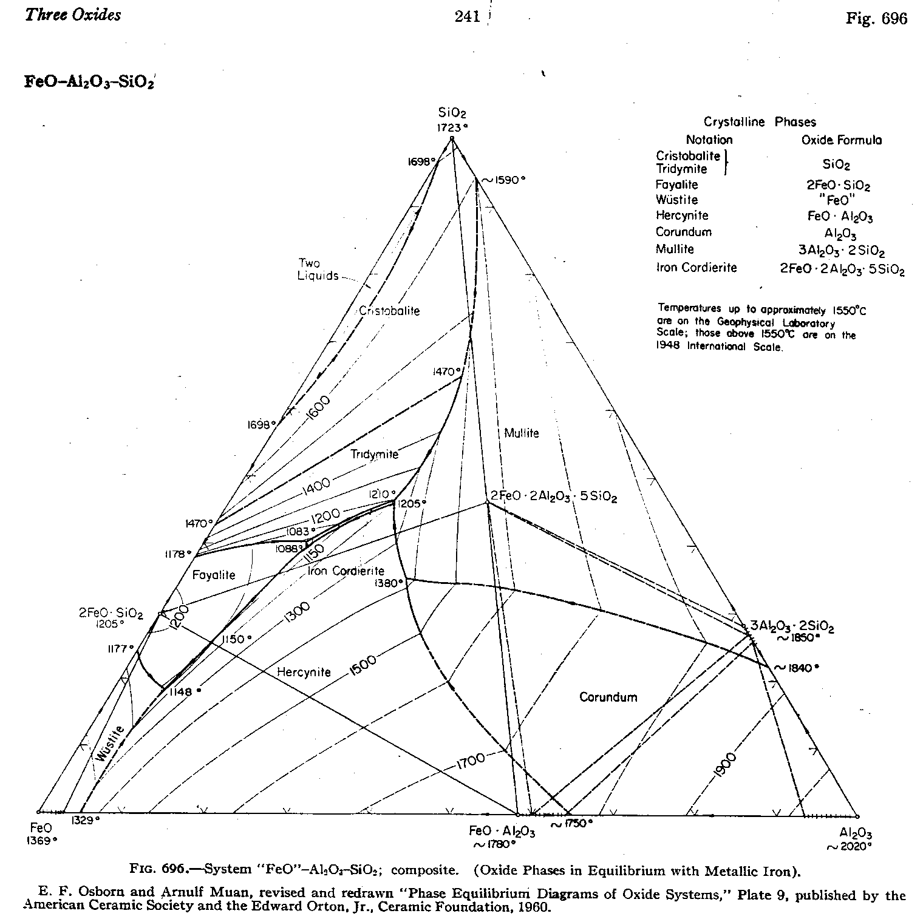

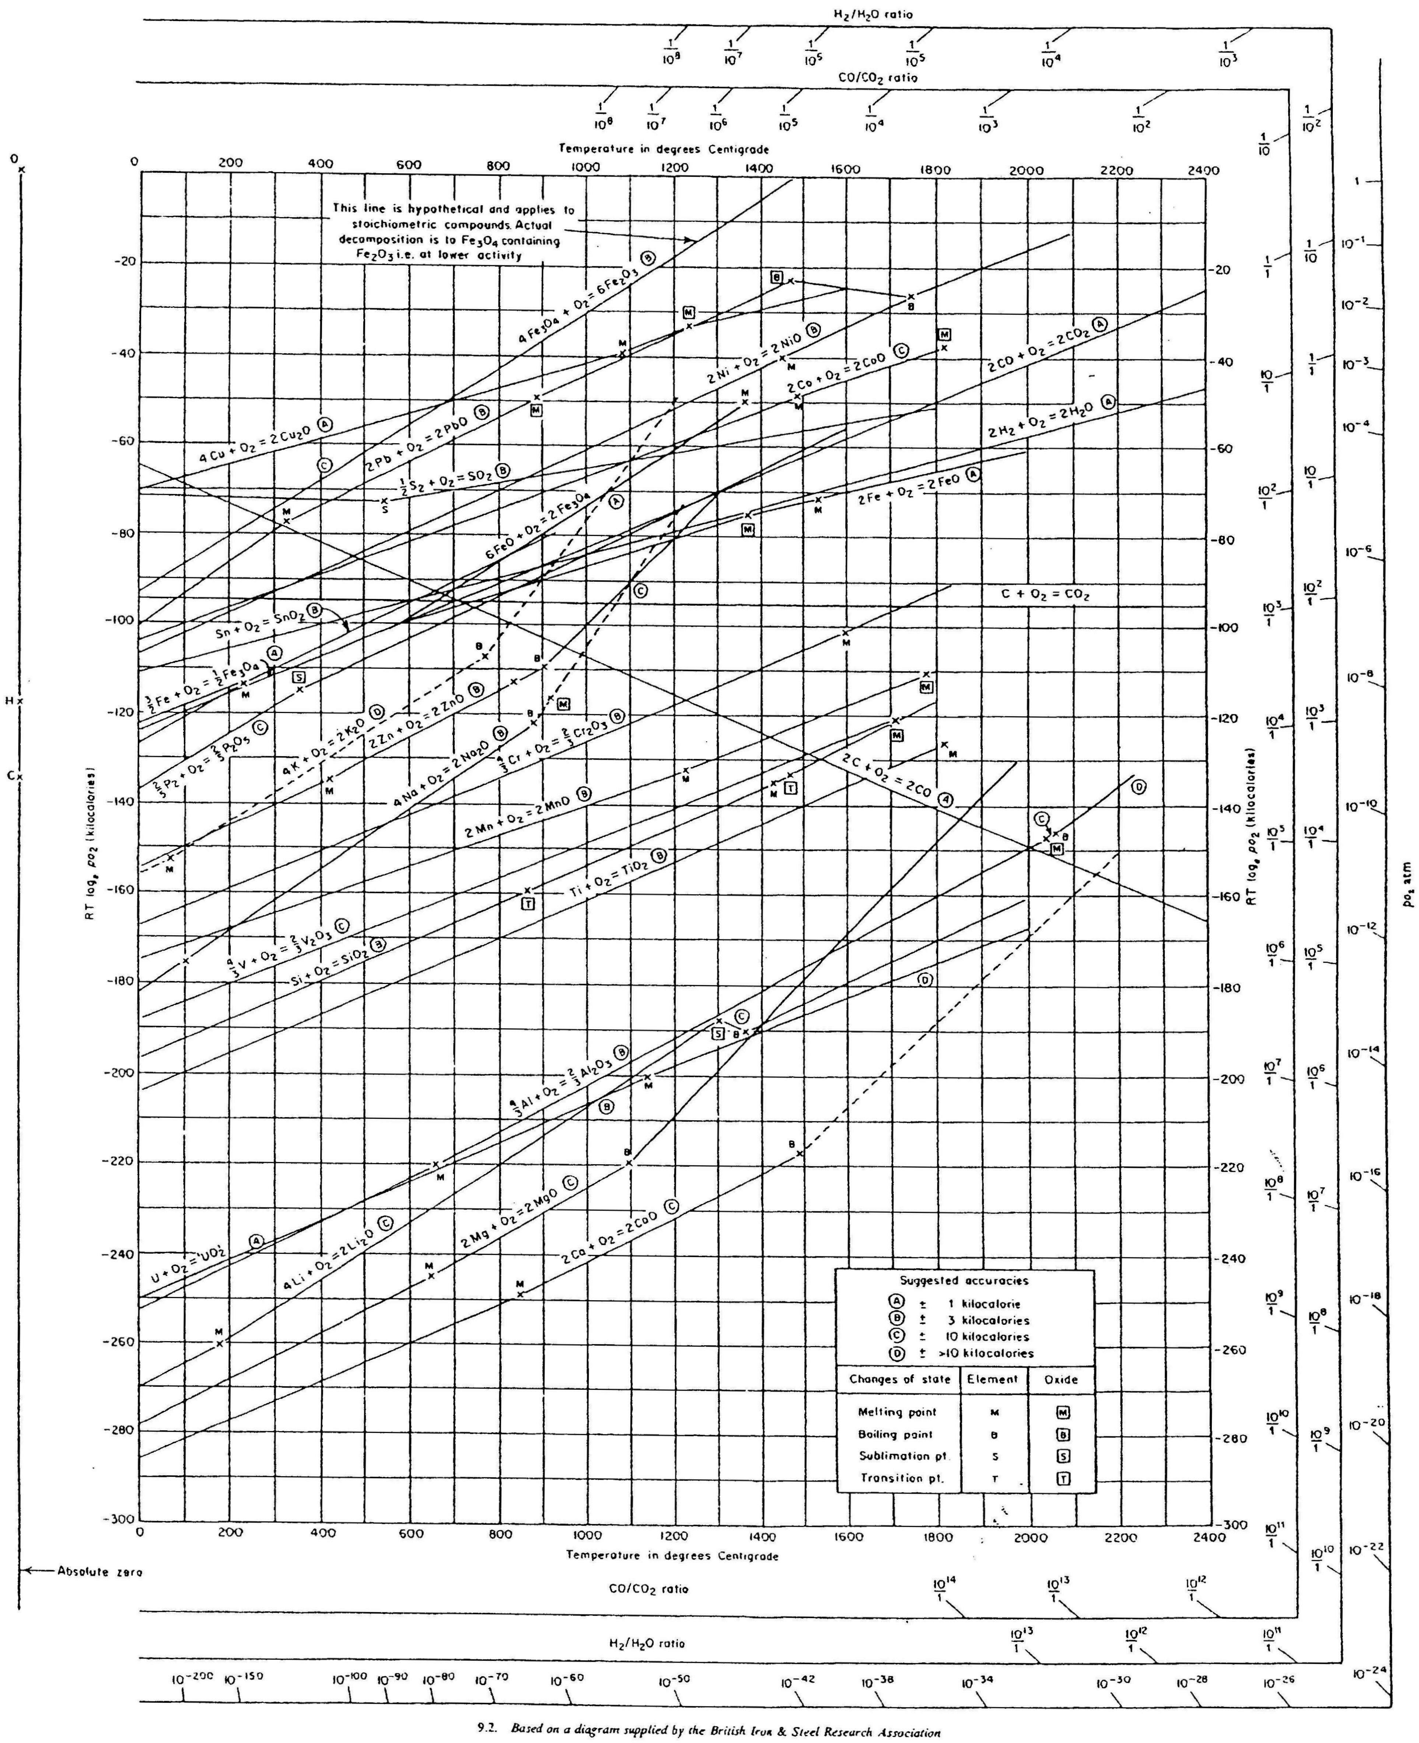
Scratch paper

