South Dakota School of Mines and Technology

### Department of Materials and Metallurgical Engineering

## Met 320 Hour Exam 3 Nov. 25, 2013

**Closed book, closed notes, no calculators**

**Fig 8.4 and Table 8.1 from Gaskell attached.**

**There is no need for Tables A1-A5 from Gaskell.**

Constants: R = 1.987 cal/K•gmole = 8.31 J/K•gmole

1. Using the attached Ellingham Diagram
2. Find the pressure of O2 in equilibrium with Ti and TiO2 at 1200 °C
3. Find the CO/CO2 ratio in equilibrium with Ti and TiO2 at 1200 °C
4. Find the Heat of Fusion for Mn
5. Determine the direction of the reaction 2Mn + SiO2 = Si + 2MnO at 1200 °C
6. Darken the line(s) that show(s) the relative oxygen potential fixed by C.
7. Short Answer
8. What event determines the critical temperature?
9. How many roots does an equation of state for a real gas have for volume at a fixed temperature below the critical temperature?
10. What is the difference between G and Gº?
11. By what method does one get one partial molar quantity from another?
12. What is the definition of the activity coefficient?
13. What is Darken’s Quadratic Formalism?
14. Given a liquidus temperature, what five values are needed to compute activities from the phase diagram?
15. Show how to find the equilibrium pressure of SO3 gas in a system at 1000 K and total pressure of 3 atm if the system initially contained 7 moles of SO2 gas and 2 moles of SO3 gas. The predominant reaction is

SO3 (g) = 0.5 O2 (g) + SO2 (g) KEQ = 0.53

1. From the below data
   1. Find $G_{Al}^{M}$ and $G_{Au}^{M}$ at $X_{Al}$ =0.3
   2. Find the activity of Au relative to pure liquid Al in a liquid Al-Au alloy at 1338 K that is 30 atomic percent Al



1. A 72.4 liter tank containing 1,000 gram moles of NH3 was in a room that reached an estimated temperature of 406 K during a nearby fire. The Ideal Gas Law gives that the pressure in the uncertified storage tank reached 460 atm (6,764 psi), which should have caused catastrophic failure (explosion). A consulting engineer reported that the maximum pressure in the tank was more nearly 111.5 atm; approximately 20 percent of the pressure calculated by the Ideal Gas Law. Why is the lower pressure closer to the correct pressure? Be specific. Use numbers. You may assume all the calculations above are performed correctly.
2. Calculate the Gibbs energy change for the oxidation of liquid Al with an activity of 0.0021 by O2 at a pressure of 1x10-8 ATM to form pure, solid Al2O3 oxide. The temperature is 1338 K.

2/3 Al(l) + O2(g) = 4/3 Al2O3 (s) G°1338 K = -711,620 Joules/gmole O2

1. Given the below data for the liquid Cu-Sn system at 1400 K determine the enthalpy change
2. when 6 moles of Sn is dissolved in a large quantity of Cu-Sn alloy having a mole fraction of Sn of 0.6.
3. when 6 moles of Sn are mixed 4 moles of Cu.

Note: Assume all components start in the liquid state at 1400 K.

## Integral Molar Heats of Mixing for Liquid Cu-Sn Alloys at 1400 K

XSn 0.1 0.2 0.3 0.4 0.5 0.6 0.7 0.8 0.9

 (cal/mole) -666 -979 -934 -715 -475 -264 -97 13 52

$H_{Sn}^{M}$ (cal/mole) -5233 -1901 252 706 681 506 311 176 49

**Data Sheet**

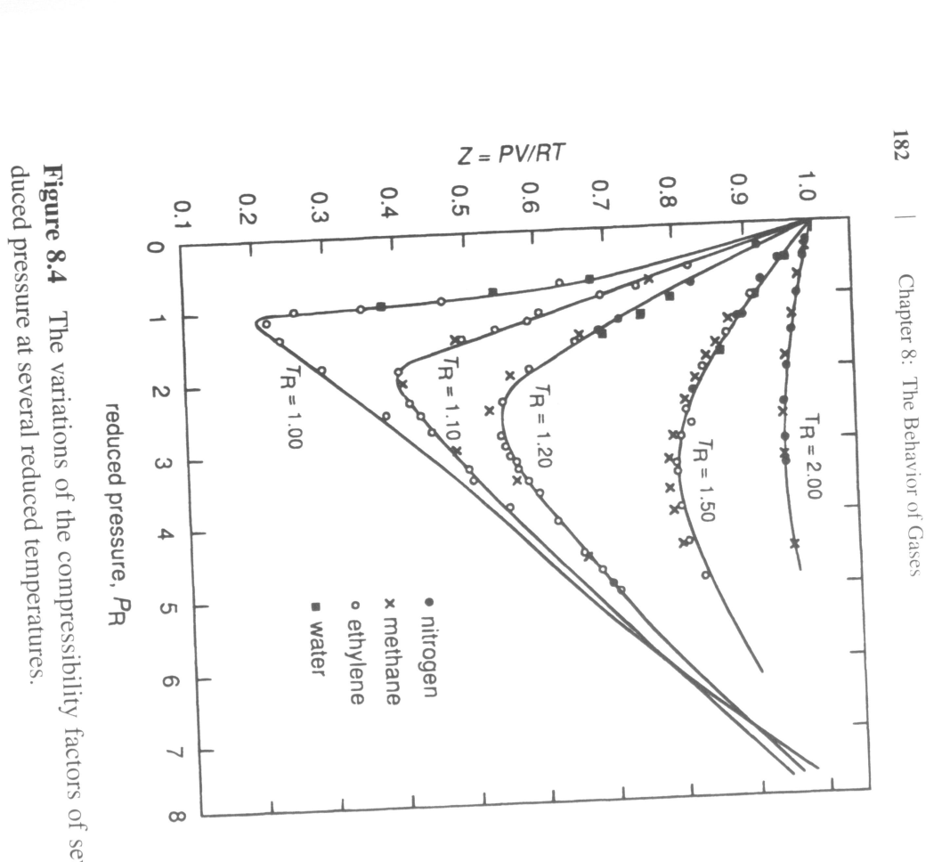

Ref: David R.Gaskell, Introduction to the Thermodynamics of Materials, 5th ed.

|  |  |  |  |
| --- | --- | --- | --- |
| **Critical properties for selected gases** | | | |
| **Gas** | **Tcr, K** | **Pcr, atm** | **Vcr , cm3/mole** |
| He | 5.3 | 2.26 | 57.6 |
| H2 | 33.3 | 12.8 | 65.0 |
| N2 | 126.1 | 33.5 | 90.0 |
| CO | 134.0 | 35.0 | 90.0 |
| O2 | 15.4 | 49.7 | 74.4 |
| CO2 | 304.2 | 73.0 | 95.7 |
| NH3 | 405.6 | 111.5 | 72.4 |
| H2O | 647.2 | 217.7 | 45.0 |
| Ref: David R.Gaskell, Introduction to the Thermodynamics of Materials, 5th ed. | | | |

Ellingham Diagram

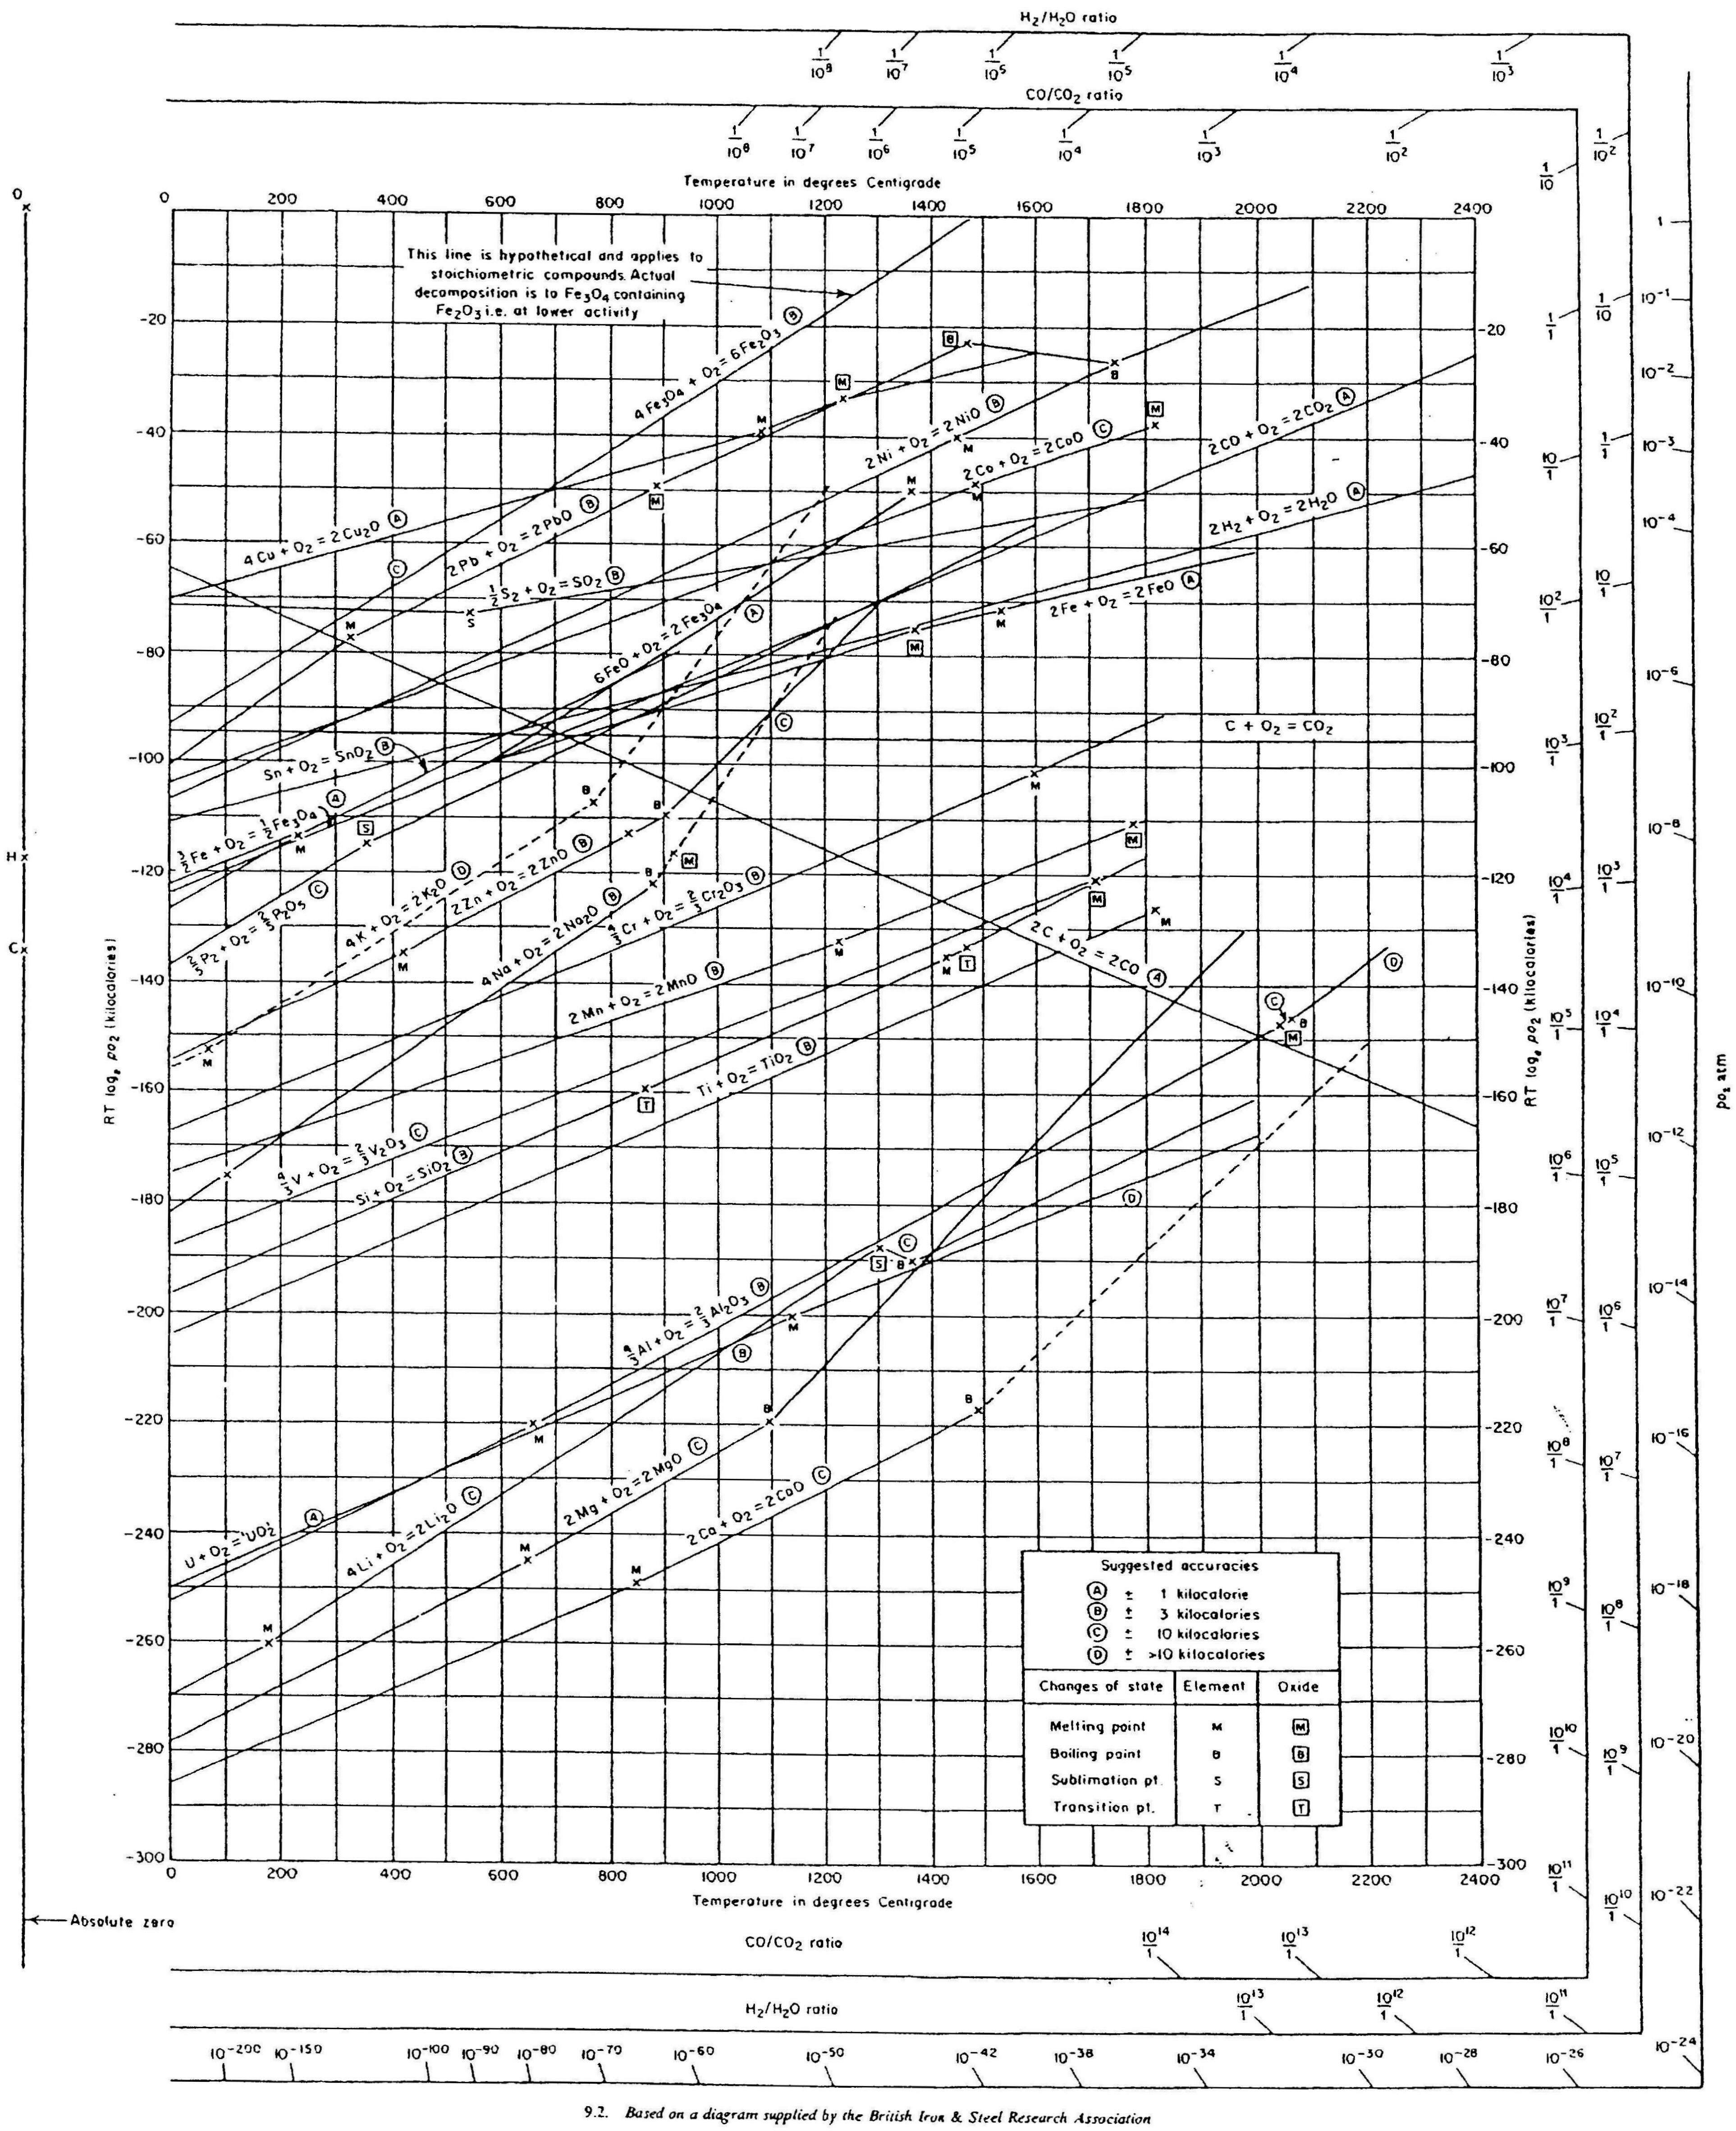

Scratch paper