South Dakota School of Mines and Technology
Department of Materials and Metallurgical Engineering

MET 320 Final Exam Dec. 15, 2005

SEE DATA SHEET AT END OF EXAM - NO CALCULATORS – CLOSED BOOK AND NOTES
If a problem seems to be in error, state the trouble, state an assumed correction, and proceed.

1. CaO-Al₂O₃-SiO₂ (C-A-S) Ternary Phase Diagram
Show all constructions on the diagram.
a) For the bulk composition marked “1”, what is the bulk composition’s
i) Percent SiO₂ = __________

ii) Percent CaO = __________

- For the bulk composition marked “1”, what is the 1st crystal to appear upon cooling?

- For the bulk composition marked “1”, what are the final 3 crystals?

- For the bulk composition marked “2”, what percent liquid is present at 2200 °C

2. Ellingham Diagram
Write your answers below and label construction lines on the attached Ellingham Diagram.
a) The pressure of O₂ in equilibrium with Ti and TiO₂ at 1000 °C.

b) The H₂/H₂O ratio in equilibrium with Ti and TiO₂ at 1200 °C.

c) The CO/CO₂ ratio in equilibrium with Ti and TiO₂ at 1200 °C.

- Label a circle showing the general region of the most noble metals on the diagram.

- Label a circle showing the general region of the most stable oxides on the diagram.

- Draw an arrow on the diagram showing the direction of decreasing oxygen potential.

- How would one convert the ΔGº values to standard cell voltages E°?

- Describe what you think would happen if Cr₂O₃, Cr, Ca, and CaO were placed together in a reactor at 1400 °C.
3. JANAF Thermochemical Tables
Determine the
a) Heat required at constant pressure to raise two gram moles of pure, solid alpha Ti from 298 K to liquid Ti at 2000 K.

b) The ΔHº reaction at 1500 K for

2Mg_{(L)} + TiCl_{4 (G)} = 2MgCl_{2 (L)} + Ti_{(S, Beta)}

c) What is ΔG at 1000 K for the reaction below.The activity of Mg relative to pure, liquid Mg is 0.2, the pressure of titanium tetrachloride is 0.1 atm, the magnesium chloride is pure liquid, and the Ti is pure solid alpha.

2Mg_{(L)} + TiCl_{4 (G)} = 2MgCl_{2 (L)} + Ti_{(S, Alpha)} ΔG°_{1000 K} = -77.0 Kcal/gfw

4. Write the first four of Big 6 equations (exclude aqueous state) and describe the standard state for each.
5. Find the adiabatic flame temperature for the combustion of CH4 with O_{2 (g)}. The O₂ and the CH4 start at 298°K. Use the provided JANAF data.

CH4 (g)+ 2O2(g) = CO2 (g) + 2H2O(g)

6. What voltage would be required to produce Mg_{(S)} from MgCl_{2 (L)} at 1000 K? (Use JANAF Thermochemical Table for data.)
Mg_{(L)} + Cl_{2 (L)} = MgCl_{2 (L)}

7. What would be the equilibrium pressure of SO₃ gas in a system at 1000 K and total pressure of 6 atm if the system initially contained 2.3 moles of SO₂ gas, no SO₃ gas and 0.8 mole of O₂ gas. The predominant reaction is

SO_{2 (G)} + 0.5 O_{2 (G)} = SO_{3 (G)} K_{EQ} = 1.88

- Show how to find the activity and the activity coefficient of Au in a liquid Au-Cu alloy at 1550 K that is 0.20 mole fraction Cu from the following data:

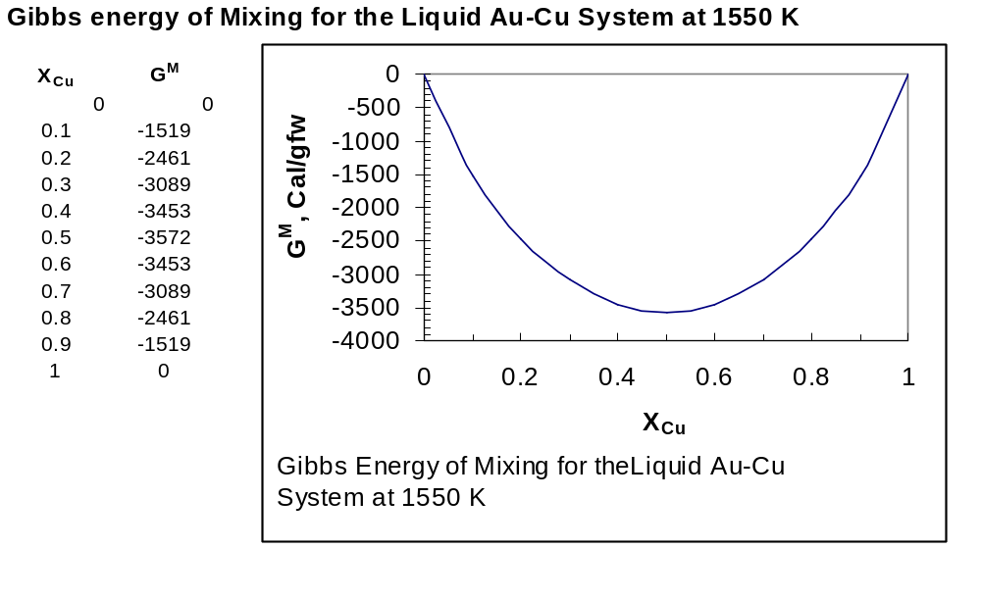

9. One mole of ideal monatomic gas at 2 atm and 500 K undergoes a reversible, straight-line transition on a P-V plot to 10 atm and 1000 K. Find the amount of heat exchanged with the surroundings and described the direction (if any) of the heat exchange.

10. Three moles of ideal gas at 300 K and 1 atm are isochorically pressurized to 3 atm while exchanging heat with a heat sink at 1000 K. Find the final ∆S for the
- gas

- heat sink.

- Complete the Fundamental Equations for a closed system

dU = TdS - PdV

dH =

dA =

dG =



